Underkløftens Hule

*A subterranean lake-city shimmering with strange life, divided loyalties, and something deeply wrong in the water…*

Jobs:

* Valdemar: Fang en 2 meter regnbue fisk så han kan få en Hule-Tunge gratis.
* Xiao: Dræb dværge-ingeniørs ærkefjende ork klan leder ude fra byen.

**🧭 OVERVIEW**

The party arrives via magical portal in a vast underground cavern dimly lit by glowing fungi, algae, and occasional floating lights. A wide, black lake stretches out in front of them, a single small boat bobbing gently at the shore. Across the water and partially carved into the stone is **Underkløftens Hule**, a bustling underground settlement. Smoke, lights, and distant music hint at life and strange opportunity.

The players are free to explore the city and surrounding zones by navigating a **pointcrawl structure**. Each node contains key factions, opportunities, and dangers. Some areas are reachable by footpaths, others by boat or underground ferries.

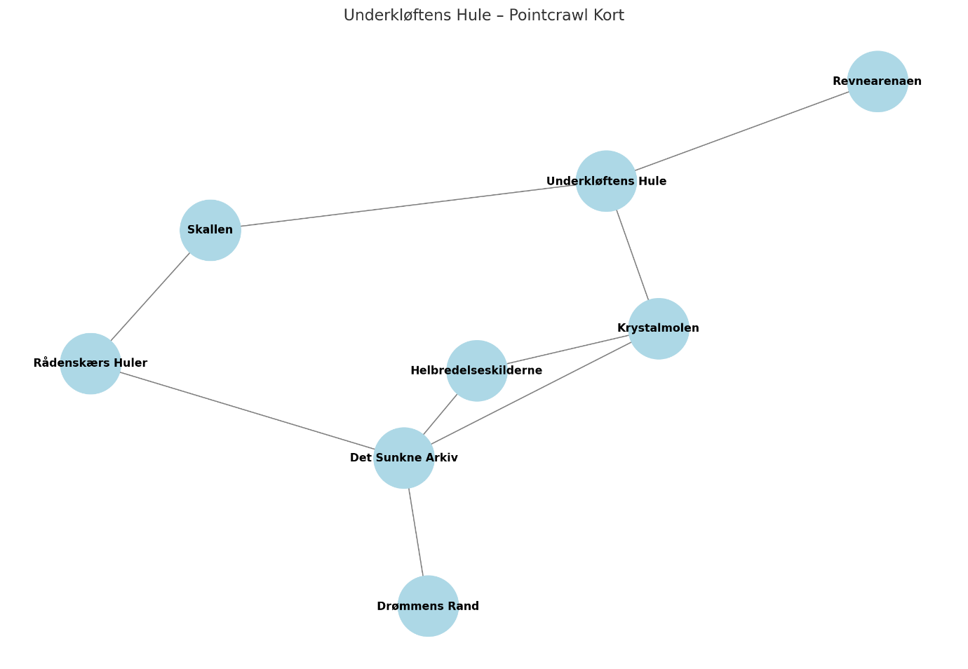

**🎯 OVERARCHING NARRATIVE**

**Problem:**  
A magical disease—called **Skælstillelsen**—is spreading through **Underkløftens Hule**. Victims slowly become sluggish, their scales or skin losing color and hardening like stone. Eventually, they fall into comas. The disease is not natural.

**Mystery/Root Cause:**  
An ancient magical fish called the **Måneskælleviathanen** slumbers deep beneath the lake. Its dreams are leaking into the world due to recent magical disturbances. These dream-energies twist reality, spread strange illnesses, and awaken dark things.

**Conflict:**  
Two major factions vie for control over what to do:

* One wants to preserve **Leviathanen** and heal it.
* The other wants to **hunt and harvest its magic**, believing the disease is its punishment for being ignored too long.

**🕸️ POINTCRAWL LOCATIONS**

Below are 8 locations in a node-based structure. Each location has at least one connection to 2–3 others. Players can reach them by boat, on foot, or via tunnels/gondolas.

**🏙️ 1. Underkløftens Hule (Main City)**

**Factions Present:** **Hule Rådet** (neutral–fractured alliance), merchants, fighters, fishers.  
**Activities:**

* Explore neighborhoods and meet locals.
* Learn about **Skælstillelsen**.
* Join the arena tournament or take side jobs (fighting or otherwise).
* Get roped into faction politics.

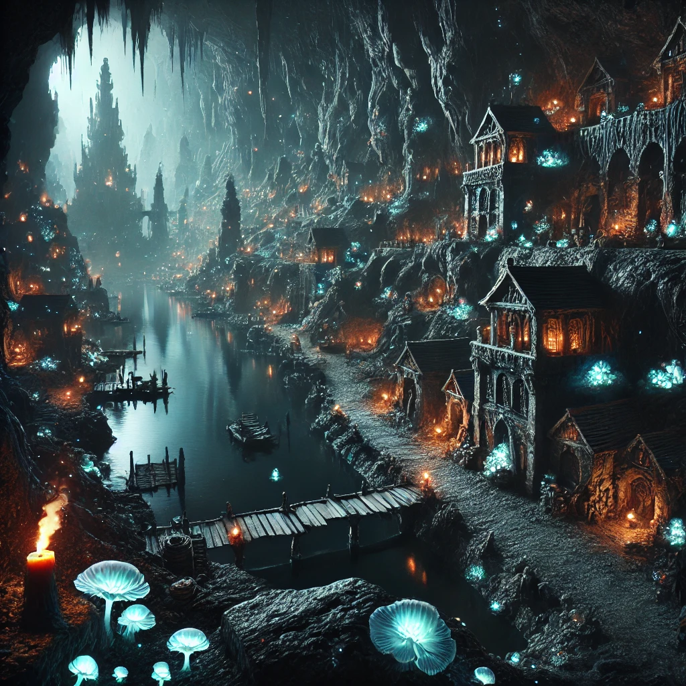

**⚔️ 2. Revnearenaen**

Carved into a lava-cracked basin with floating platforms and stone seats.  
**Run by:** A cheerful duergar named **Tippa Revnekæbe**, obsessed with “showmanship.”  
**Activities:**

* Non-lethal fights for glory, prizes, or information.
* Faction champions appear as recurring opponents.
* Winners earn prestige (or favors).  
  **Hook:** **Tippa** suspects **Skallen** is rigging fights magically.

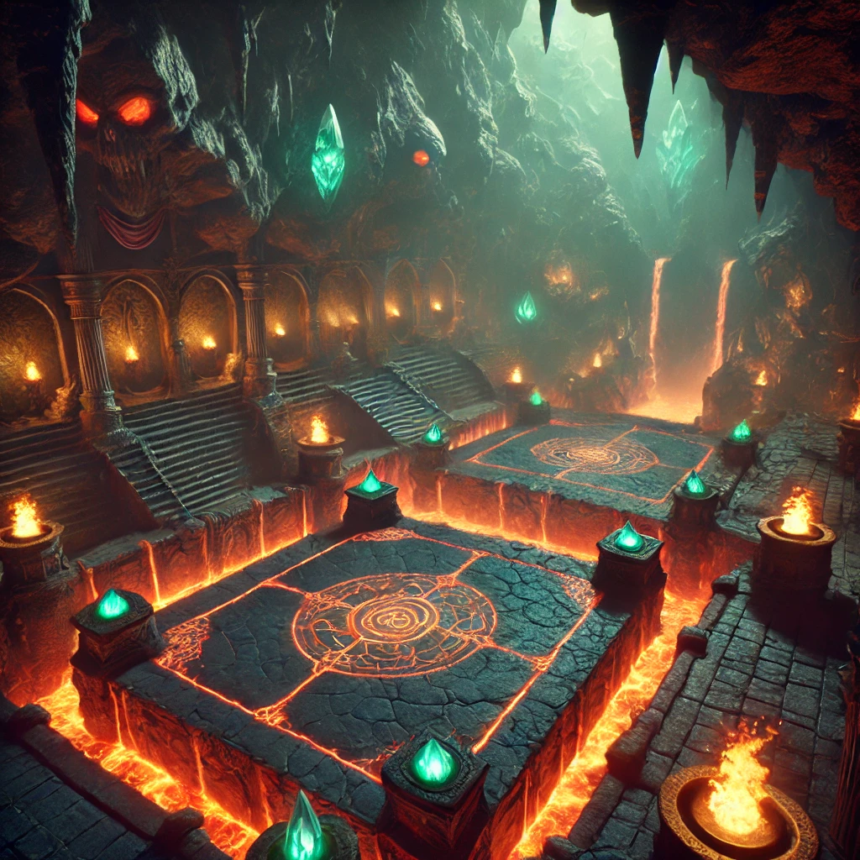

**🕳️ 3. Skallen (Black Market)**

Hidden behind a rotating stone wall, this glimmering cavern is full of glowing dice, whispered deals, and shimmering creatures in cages.  
**Factions Present:** **Blindsnegle-Syndikatet** (secretive, morally gray).  
**Activities:**

* Gambling games with weird magical twists.
* Buy minor magic items and illegal fish-related curios.
* Rumors about the disease being “profitable.”  
  **Non-combat hook:** The Syndicate is trafficking diseased creatures to harvest dream-essence—can the party uncover or stop them?

Hule-Tunge. Shapeshifter der kan klatre op på loftet og hænger tunge ned, ala Half Life.

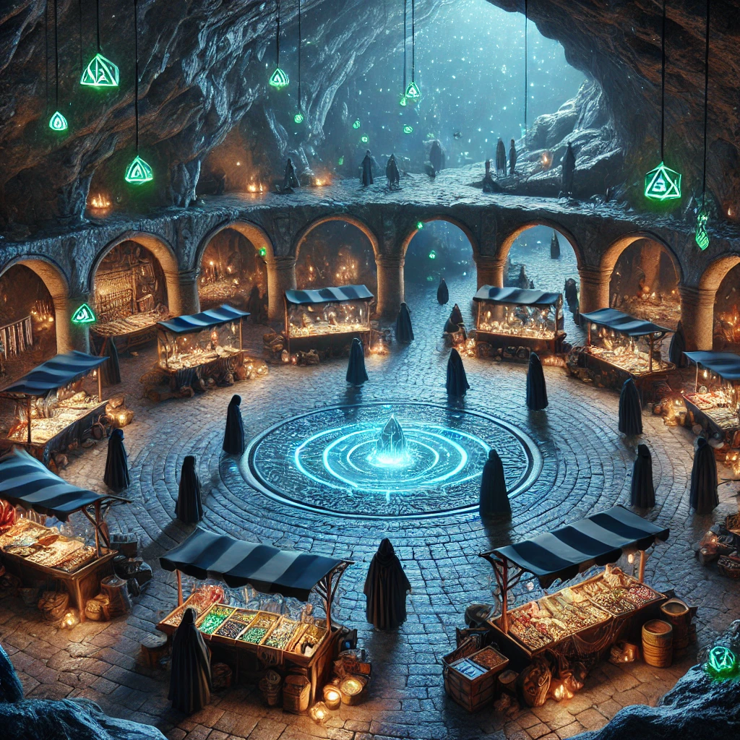

**🎣 4. Krystalmolen**

A quiet fishing dock that stretches out into the glowing lake.  
**Factions Present:** **Fiskerlauget**, a few old mystics.  
**Activities:**

* Fish for rare magical species. Some fish affect memories, dreams, or status effects.
* Old fisherfolk know lore about **Leviathanen**.
* Children from the city play here; one is sick and growing silver scales.  
  **Hook:** One magical fish only appears in dreams. How do you catch that?

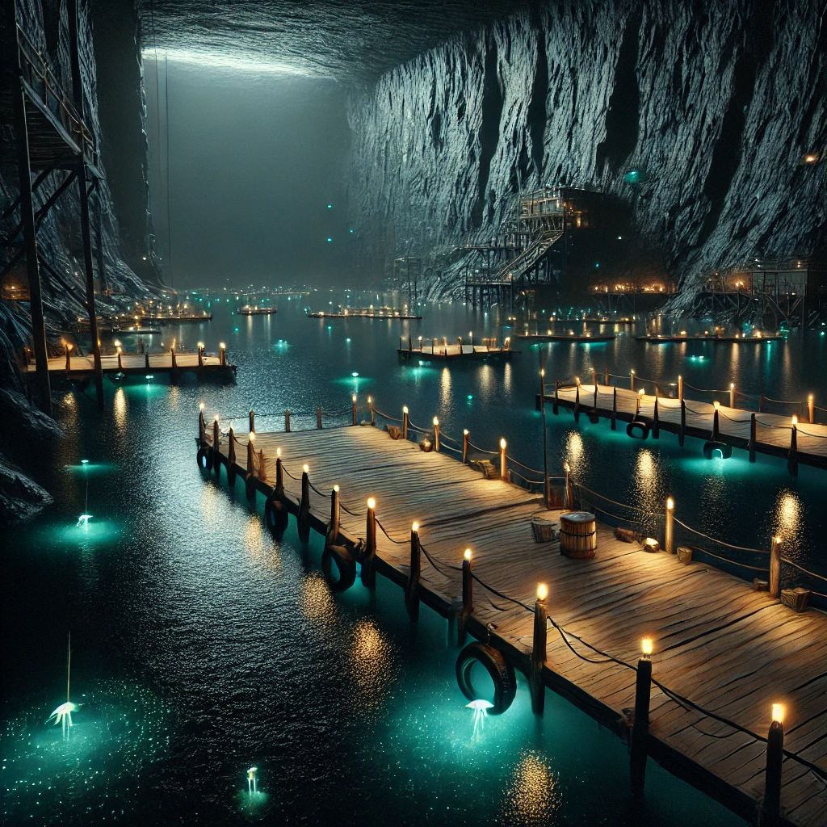

**💀 5. Rådenskærs Huler**

A slimy warren of flooded caves where **Rådenskærs Sværmen** (evil aberration cultists—think mutated kuo-toa or grimlocks) are worshipping **Leviathanens** dreams and feeding on blight-infected hosts.  
**Factions:** Enemy only.  
**Hook:**

* They want to **awaken Måneskælleviathanen permanently** to drown the surface world in dreams.
* The party can infiltrate to gather intel or disrupt rituals.  
  **Combat-heavy**, but creative options (sabotage, disguise) are possible.

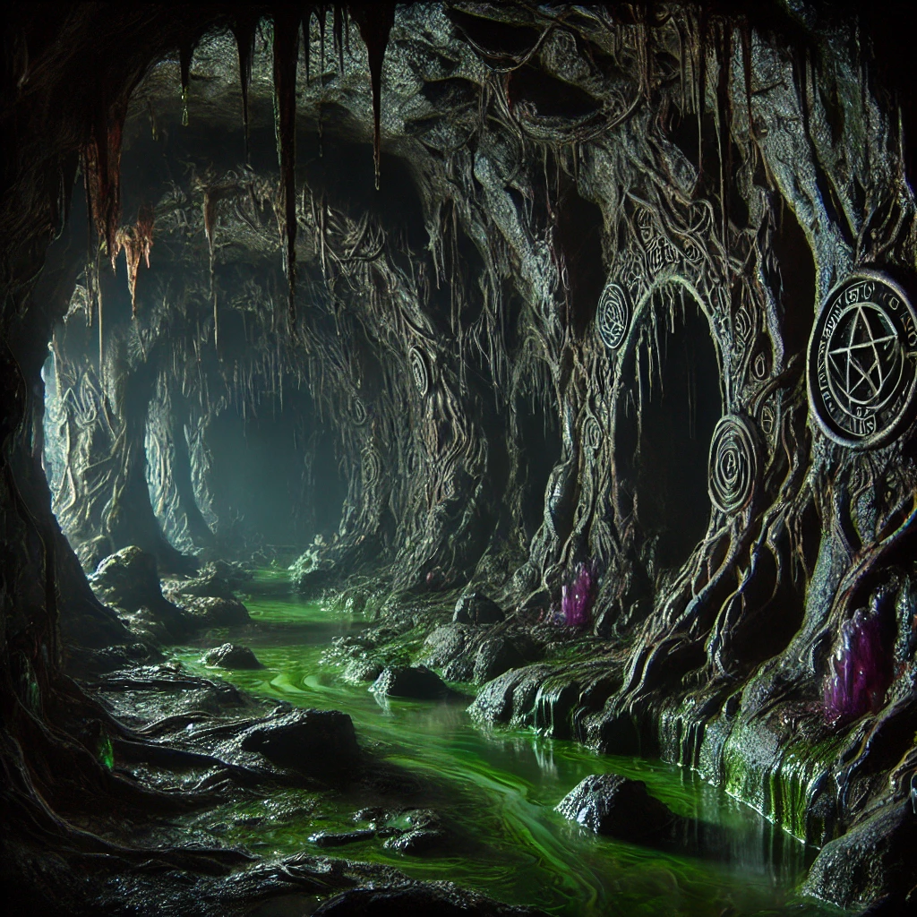

**💧 6. Helbredelseskilderne ved Iridas**

Hidden warm springs with strange purifying energy.  
**Factions Present:** **Iridas' Præster** (neutral-good water spirits).  
**Activities:**

* Learn about the spiritual connection to the lake.
* Help them diagnose magical anomalies.
* Earn a **blessing** that protects from disease or grants limited water-walking.  
  **Non-combat Hook:** The waters are fading—why? Discover the corruption is spreading even here.

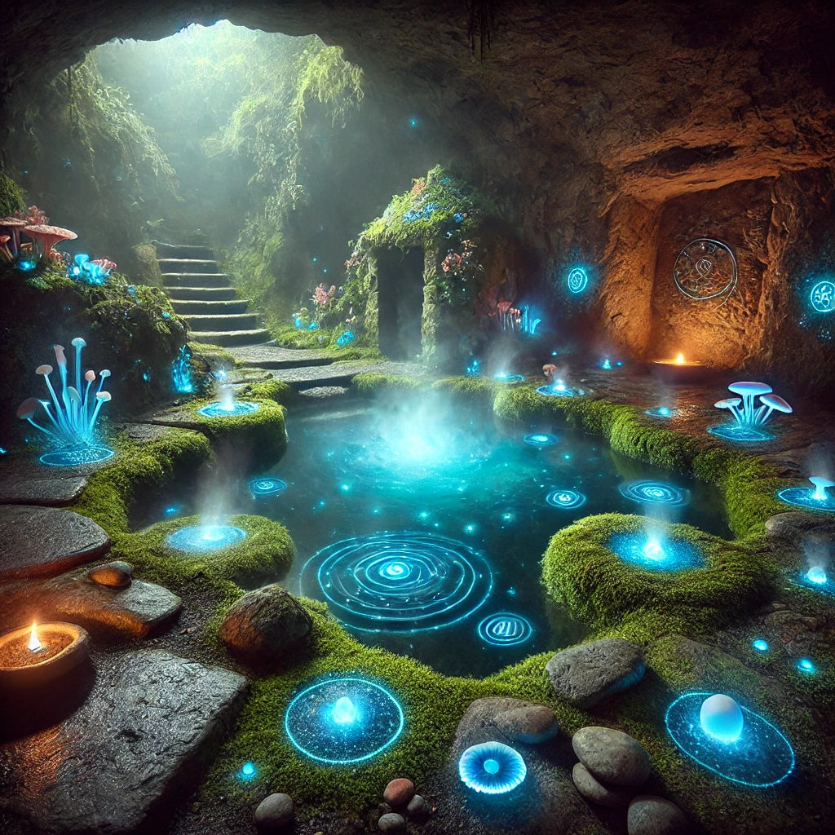

**🛶 7. Det Sunkne Arkiv**

A half-collapsed temple under the lake, only reachable by submerging or using magical air-bubbles.  
**Factions Present:** No living ones, but spirits may linger.  
**Activities:**

* Discover ancient murals showing **Leviathanens** origin.
* Solve puzzles or avoid guardians to retrieve sacred knowledge.  
  **Hook:** Key to stopping **Skælstillelsen** lies here—but the dreams make the temple shift like a dream maze.

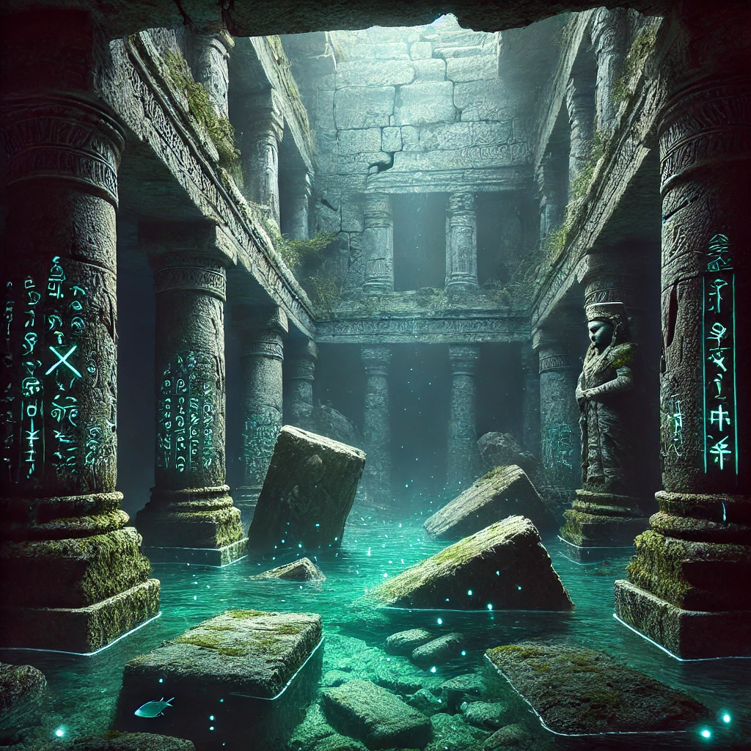

**🧠 8. Drømmens Rand**

The deepest point of the lake, swirling with dark currents.  
**Factions Present:** None—only the **subconscious of Måneskælleviathanen**.  
**Activities:**

* Confront dream-walkers, illusions, or emotional puzzles.
* Try to **enter the Leviathan’s dreams** and help calm it.  
  **Final Hook:** Do the players destroy the source, or try to cure **Leviathanen**?

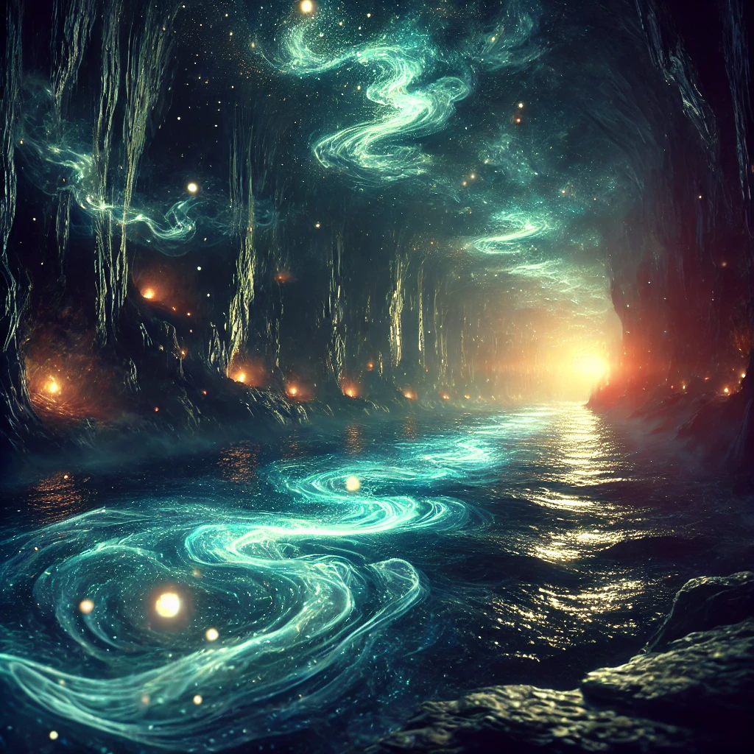

**🎁 OPTIONAL EXTRAS**

* **Fishing Minigame**: Make fishing interactive—use skill checks, bait choices, or magical fishing rods to determine what’s caught. Some fish may talk, others grant visions, others escape with clues in their scales.
* **Gambling Mechanics**: Use fun dice-based minigames. You could have one with wild magical surges on wins/losses!
* **Arena Events**: Let players fight illusions, magical constructs, or even do non-combat performances or obstacle runs.

Communities

**🐾 Vandrefangens Børn *(Tabaxi community)***

* **Core Identity:**  
  A tight-knit clan of Tabaxi who venerate their ancestors through rituals involving still water. They believe reflections are sacred channels—“mirror-paths”—through which the spirits speak and guide the living.
* **Crisis:**  
  Since the spread of **Skælstillelsen**, the waters have become “clouded.” Reflections no longer show the ancestors. Many Tabaxi fear their spirits are trapped or in danger. Some have begun to lose faith or act erratically.
* **Key NPCs:**
  + **Spejlmor Tama**, an elderly Tabaxi priestess who believes the *Måneskælleviathanen* is dreaming too loud, drowning out the ancestors.
  + **Stilleflod**, a young Tabaxi dream-diver who wants to enter the lake and “walk the mirror-paths” directly—he may drag a PC into a reckless ritual.
* **Adventure Hooks:**
  + Help the Tabaxi restore a sacred mirror pool.
  + Perform a ritual in **Det Sunkne Arkiv** to recover a “lost reflection.”
  + Learn a non-combat method of communicating with the Leviathan—through dreams or mirrored waters.

**🐉 Askeskæl-Klyngen *(Dragonborn enclave)***

* **Core Identity:**  
  A proud but dwindling Dragonborn community who came here generations ago, drawn by tales of power in the deep. They settled in **Underkløftens Hule** and carved a district of black stone homes adorned with volcanic ash murals.
* **Beliefs & Values:**  
  Honor, legacy, and preservation. Many revere **the Leviathan as a sleeping sibling of dragonkind**, and some believe its dreams must be protected—others believe they must be silenced.
* **Split Loyalties:**  
  The community is divided between those who want to help the sick and those who want to weaponize the Leviathan’s power to restore Dragonborn greatness.
* **Key NPCs:**
  + **Glødpust**, a red-scaled warrior-poet who sees the Leviathan as a divine test.
  + **Emberisk**, a sickly old scholar who once dreamt beside the lake and emerged with forgotten draconic prophecies.
  + **Your PC’s Family or Friend** could be woven in here—a cousin, sibling, or rival with a strong opinion.
* **Adventure Hooks:**
  + Retrieve a prophetic relic lost in **Drømmens Rand**.
  + Mediate a dispute between the factions.
  + Use draconic rites to calm or channel Leviathan energy.

**🐟 Rådenskærs Sværmen *(Leviathan cultists)***

* **Core Identity:**  
  Secretive worshippers who dwell in **Rådenskærs Huler**. They believe the Leviathan’s dreams are sacred truth, and the world above must be “reshaped” in its image. Over time, they undergo physical mutations—gills, bulbous eyes, scaled skin.
* **Inspiration:**  
  Lovecraftian horror (like *The Shadow Over Innsmouth*) but made kid-appropriate by emphasizing eerie weirdness over gore. They whisper in bubbles. They shed tears of seawater. They fear silence.
* **Goal:**  
  Awaken the Leviathan fully and allow its dreamworld to spill into reality. This would permanently change the cavern—and possibly the players.
* **Key NPCs:**
  + **Visker-Kaldet**, a high priest who speaks only in riddles and reflections.
  + **Sørgmodig Søster**, a cultist who regrets joining and could become an ally if shown kindness.
* **Adventure Hooks:**
  + Discover where their rituals are taking place and sabotage them.
  + Find a captured Leviathan-scale and destroy it or use it to attune to its dreams.
  + Choose: seal the cult away forever, or attempt to redeem some of them.

**🧂 Perleskinnerne *(Neutral merchants and gossipers)***

* **Core Identity:**  
  A nomadic group of gnome and halfling traders, entertainers, and information brokers. They control many stalls in **Skallen** and love fish-based metaphors ("He’s slipperier than a three-eyed mudsnapper").
* **Tone:**  
  Mischievous, flamboyant, clever—but not evil. They hedge their bets and play all sides. They might help the players—if it’s profitable or amusing enough.
* **Key NPCs:**
  + **Nifta Perleblink**, a gnome illusionist who runs magical shell-game scams.
  + **Bendt Kriller**, a halfling who smuggles dreamfish in glass orbs.
* **Adventure Hooks:**
  + Gamble for rare intel—risk winning or losing a “memory fish.”
  + Help them retrieve a stolen magical item before it falls into cultist hands.
  + Use their hidden tunnels to sneak into **Rådenskærs Huler**.

**🏛️ Hulerådet**

*The City Council*

**Symbol:** 🏛️ A cracked stone circle with seven glowing dots  
**Who they are:** The leaders of Underkløftens Hule—a mix of old merchants, wise fishers, priests, and adventurers who can never agree on anything.

**What they want:** To keep the city from falling apart… but they argue constantly about how to do it.

**Why you care:** They have power, maps, and money—but they might ask for your help to settle a vote or uncover a secret.

**Vibe:** Grumpy but important adults who need help more than they’ll admit.

**🐾 Vandrefangens Børn**

*The Tabaxi Ancestor Seekers*

**Symbol:** 🐾 A pawprint reflected in water  
**Who they are:** A group of Tabaxi who talk to their ancestors through water reflections. One of you is from this group!

**What they want:** To bring back the reflections and find out what happened to the voices of the dead.

**Why you care:** They know about the spirits, and might help you enter dream-realms or learn ancient secrets.

**Vibe:** Mysterious, wise, sad. Their magic is quiet and deep.

**🐉 Askeskæl-Klyngen**

*The Dragonborn District*

**Symbol:** 🐉 A dragon's head with smoke rising from its nostrils  
**Who they are:** A group of proud Dragonborn who believe the Leviathan is a sleeping dragon—or its cousin.

**What they want:** To protect their history and maybe use the Leviathan’s power to restore their strength.

**Why you care:** They have dragon-magic, ancient scrolls, and strong fighters. One of you might even be part of this group!

**Vibe:** Tough, noble, divided. Some are wise leaders. Some want power.

**🐟 Rådenskærs Sværmen**

*The Fish-Cult*

**Symbol:** 🐟 A three-eyed fish surrounded by bubbles  
**Who they are:** Strange, shadowy people turning into fish. They whisper to the Leviathan and want to wake it up.

**What they want:** To flood the world with the Leviathan’s dreams.

**Why you care:** They’re spreading the disease. You might need to sneak past, stop, or even help someone trapped in their group.

**Vibe:** Creepy, whispery, dangerous—but not all of them are beyond help.

**🐚 Perleskinnerne**

*The Glittery Traders of the Black Market*

**Symbol:** 🐚 A shiny clam with a grin  
**Who they are:** Gnomes and halflings who run secret stalls, games of chance, and magical trades in **Skallen**.

**What they want:** To have fun, make deals, and stay out of big fights.

**Why you care:** They know everything. You can gamble, buy strange items, or learn juicy secrets from them.

**Vibe:** Funny, clever, tricky. Not bad—but don’t trust them with your lunch money.

**🎭 INTRO-SCENE: Ankomst til Underkløftens Hule**

*Båden glider stille frem, uden en lyd, over den blanke, kulsort sø. Vandet under jer er som blæk—dybt, koldt og næsten helt stille. Rundt omkring rejser hulens vægge sig højt, så højt at I ikke kan se loftet. Kun svagt skær fra selvlysende svampe og alger kravler op ad klippesiderne som stjerner malet i mos.*

*Og så… ser I den.*

**Underkløftens Hule.**

Først ligner det bare en skygge. Så bliver det til en form. Og pludselig står den der: en by udhugget direkte ind i hulens vægge, bygget som en stentrappe ned til søens kant. Små lanterner blafrer ved smalle trapper og kringlede gyder. Krystaller i underlige farver kaster mærkelige skær hen over tagene og de gamle bygninger. Musik svæver i luften—langsom, næsten som en drøm. Og luften lugter af røg, fisk… og noget andet. Mos? Medicin? Magi?

En lang træmole strækker sig ud i vandet. Folk i hætter slæber kasser, fører mærkelige bæster, eller står bare og stirrer ned i vandet. I den fjerneste ende står én og venter.

Hun er lille og krumbøjet, pakket ind i våde klæder og små klokker, der klirrer blidt, når hun bevæger sig. En glødelampe hænger fra en kæp på hendes ryg. Da båden støder let mod molen, læner hun sig frem—og I ser hendes ansigt. Halvt dækket af små skællignende vækster. Ét øje skinner klart som en perle.

Hun taler—ikke med sin mund, men inde i jeres hoveder:

“Søen bringer fremmede med gammelt blod… og vigtige spørgsmål. Godt. I kommer, mens sygdommen spreder sig. Vandet glemmer. Fiskene drømmer forkert. *Refleksionerne er væk.*”

*Hendes øje drejer sig mod Tabaxi-karakteren.*

“Du har mærket det, har du ikke, lille snude? Stilheden under vandet. Selv de døde taler ikke længere.”

Hun træder til siden og bukker langsomt, mens hun gestikulerer mod byen.

“Gå. Find jeres svar, før drømmene bliver værre. Venter I for længe… vil der ikke være noget tilbage at vække.”

To halflings kommer glad og vifter damen væk og siger: “Aha! Nytilkommende. Og hvad er det, kan jeg lugte eventyr? Jeg er sikker på at I har lommerne fuld af guld, så kom endelig forbi vores stald på markedspladsen! Vi kan føre jer dertil med det samme?”

Brødende Rigg trillinger.